Curriculum vitea 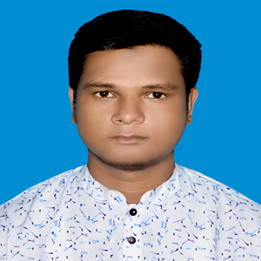

of

**MOHAMMAD SALAH**

Cell : 01813-212455

email: mdsalahuddin326@gmail.com

To serve in a responsible position at a well-structured organization and successfully apply acquired managerial and interpersonal skills to enhance organizational efficiencies.

**Name                :     Mohammad Salah Uddin**

**Father’s Name     :     Mohammad Abul Kalam**

**Mother’s Name   :** Rokeya Begum

**Date of Birth       :** January 01, 1993

**Place of Birth      :** Chittagong.

**Permanent Address :** Imam Nagar,Bhatiary,P.O.- Bhatiary,

P.S- Sitakund,Dist- Chittagong.

**Present Address    :** Same as above.

**Nationality            :** Bangladeshi.

**Religion                    :** Islam.

**Sex                            :** Male.

**Marital Status           :** Unmarried.

|  |
| --- |
| **Educational Qualification** |

**Masters of Arts (English)**

* Major     –  English
* University – National University
* Institution    – Govt. City College, Chittagong.
* Result     - Appeared
* Passing year – 2016

**Bachelor of Hon’s (English)**

* Major     – English
* University     – National University
* Institution    – Govt. City College, Chittagong.
* Result     - 2.40
* Passing year  – 2015

**HIGHER SECONDARY CERTIFICATE (Alim)**

* Group     – Humanities
* Institution    – Madrasah-E-Mohammadia Ahmadia Sunnia
* Board     – Madrasah
* Result            - GPA- 3.67
* Passing year     – 2009

**SECONDARY SCHOOL CERTIFICATE (Dhakil)**

* Group     – Humanities
* Institution    – Madrasah-E-Mohammadia Ahmadia Sunnia
* Board     – Madrasah
* Result            - GPA- 3.17
* Passing year     – 2007

|  |
| --- |
| **Working Experience/Workshop** |

* Served as a **Procurement officer** at S.L Re-rolling Mills Ltd. from March, 2014 to till now.
* **Worked as a Sales Representative In Pran Group from 2012 to 2014**
* Served as a working Steel Division as a assistant production Manager
* Had being working as a Safety Officer 6 Month In Sl Ship Re cycling Industries

|  |
| --- |
| **professional Training** |

* Training on Fire Safety & Compliances for 04.09.2015 to 06.11.2015under BGMEA.
* Participate Training on Sales & Marketing under Akij Food & Beverage Ltd. for 1 Months.
* Training On Land Survey 3 Month.

**Educational Qualification  (Study on)**

___________________

***Signature & Date***